

Government of India Ministry of Environment, Forests
and Climate Change

Journey from “Grey to Green”
A Self Assessment Manual
for
National Green Corps Eco Clubs

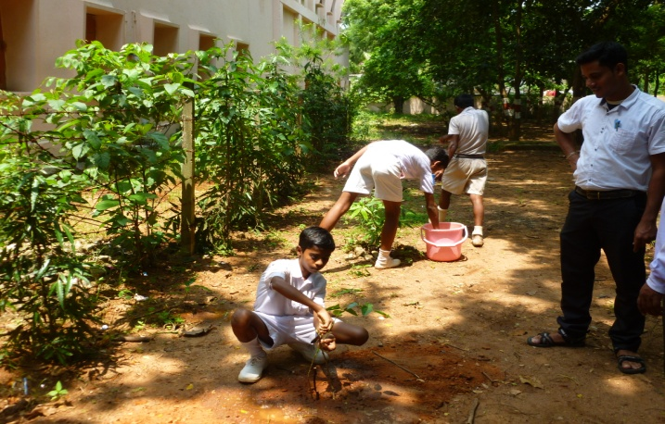
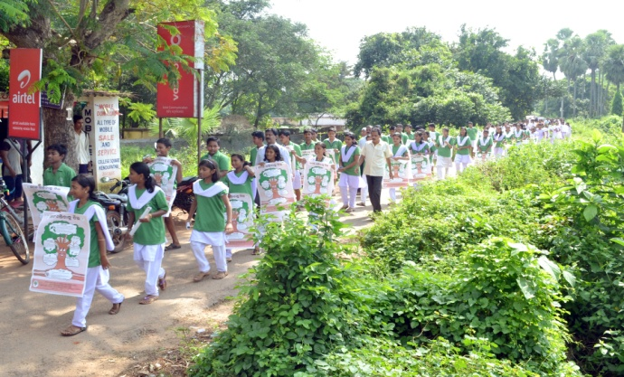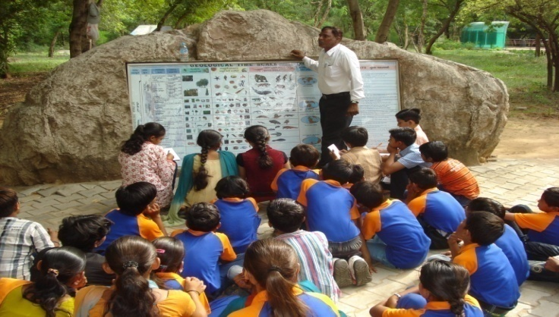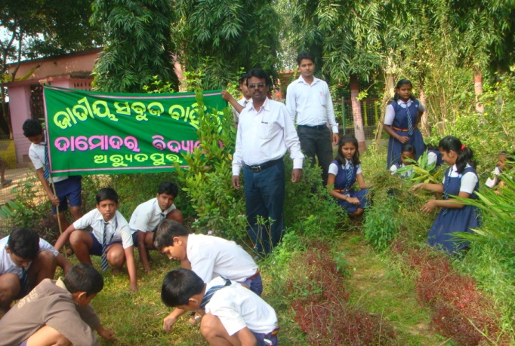

Government of India Ministry of Environment, Forests
and Climate Change

Journey from “Grey to Green”
A Self Assessment Manual
for
National Green Corps Eco Clubs

“If you have assimilated five ideas and made them your life and character, you have more education than any man who has got by heart a whole library”.
— Swami Vivekanand

Advisors: Brij Mohan Singh Rathore, IFS, Joint Secretary,
MoEFCC
Research and Compilation: Rita Khanna, Kanchan Sharma, Shrawan Kumar
Editing: Rita Khanna, Kanchan Sharma, Shrawan Kumar
Photographs: Courtesy State Nodal Agencies and Resource agencies
Design: Rita Khanna, Kanchan Sharma, Shrawan Kumar

© 2014. Ministry of Environment, Forests and Climate Change

Present manual focuses on guiding and helping teachers in assisting the eco-club students to assess outcome of activities taken up by the eco clubs. The outcome can be seen at 3 levels; i.e. at the level of individual students, the school and in the neighbourhood.
The assessment is to be carried out by the eco club students. The role of the teachers will be to act as facilitator, assisting the eco club students to see how far they have gone on the journey from “grey to green”.

Contents
Foreword
Preface
National green corps (NGC): An introduction
About the manual
Facilitator’s attribute
Exercises for self assessment
Exercise- 1: Aaoo apne Hastchap/ Hast Chinh Ko pahchane aur
bada karein

Exercise II: Journey from Grey to Green

Exercise III: Greening the neighbourhood

Attachments
I. Indicative list of activities for Exercise - 1
II. Indicative list of activities for Exercise - 2
III. Annual Reporting Format for NGC Schools.

FOREWORD
It is a well established and recognised fact that the children can be catalysts in promoting a mass movement about the ensemble of the environmental issues. Being future citizens, inculcation of environment friendly attitudes and behavioural patterns amongst them can make a significant difference to the long term efforts for protection of environment. Children are triggers for a chain reaction, making a difference at the local and community level which in due course lead to awareness at village, city, State, country and global level.
National Green Corps (NGC) popularly known as the programme of eco-clubs was initiated in year 2001-2002. It is a unique programme aimed at building a cadre of young green corps working towards environmental conservation for a more secure and sustainable planet. With more than 1,00,000 eco clubs and about 35 lakh students NGC has percolated deep at ground level to spread awareness and action to solve local environmental problems.
In view of the action oriented component of this programme, Ministry has developed a Self assessment Manual “Journey from Grey to Green” which helps in self assessing the actions done and actions yet to be done. Through this manual, students facilitated by Eco club teacher Incharge will find out the indicators of environmental issues and will give them a chance of self assessment. More importantly this manual will generate focussed discussion among students on various aspects of environmental issues.
This manual would not have been possible without the support of Centre of Excellences, enthusiastic State Nodal Agencies, Resource agencies, Eco Club Schools, Principals, Teachers. Their valuable contribution is highly acknowledged.
My best wishes to all those who are making the journey from Grey to Green.

(Brij Mohan Singh Rathore)
Joint Secretary

PREFACE
National Green Corps (NGC) initiated in year 2001-2002 has covered a long distance and now with its expanded outreach to more than 1,00,000 Eco clubs. Its been a journey in which many young minds has adapted a environmentally friendly attitude. We are extremely delighted to see the impacts of the programmes. While some of them have surrendered their bird hunting weapons, others could go to the extent of mobilizing the local community and Government to close down sand mine. The Environmental friendly attitude is visible in their actions.
The present manual “Journey from Grey to Green” is a step towards providing a interactive tool for self assessment of students. It is developed with a vision to provide a platform away from conventional mode of marking and rote methodology in our education system. It focuses on how environment awareness should not be treated as separate activity, but needs to be dealt with holistically.
Being a joint responsibility of one and all, it aims to involve the entire school community (children, teachers) and the neighbourhood to work together through participatory, practical and collaborative approaches. Able facilitation of Eco Club teacher incharge can give a shining finish to set a example for all.
It is with sense of pride that I place before you the Manual “Journey from Grey to Green”.

Rita Khanna
Scientist-‘E’

National Green Corps (NGC): An Introduction
It is a well established and recognised fact that the children can be catalysts in promoting a mass movement about the ensemble of the environmental issues. Being future citizens, inculcation of environment friendly attitudes and behavioural patterns amongst them can make a significant difference to the long term efforts for protection of environment. Children are triggers for a chain reaction, making a difference at the local and community level which in due course lead to awareness at village, city, State, country and global level. Ministry of Environment Forests and Climate Change (MoEF & CC) has hence, embarked upon a major initiative for creating environmental awareness among children by formulating National Green Corps (NGC) through Environment Education Awareness and Training Scheme of Ministry
National Green Corps, popularly known as NGC is a national programme conceptualized and initiated by the Ministry of Environment and Forests AND Climate Change, Government of India. As the name suggests, it is a programme to sensitize school children about environment, its problems and conservation. Started in the year 2001, the programme is operational across the country through school eco-clubs established for this purpose. The programme with its network of more than 1,00,000 schools and about 35 lakh students has promoted awareness and action to solve local environmental problems. MoEF had initially aimed at 50,000 Eco clubs in this nation wide programme. The phenomenal response that NGC has received has made the network more than 1,00,000 Eco clubs across the country in 10 years, making it one of the largest conservation networks. The unique partnership between the MoEF, the states Government agencies along with the dedicated NGOs, working in the field of Environmental Education has contributed to the success of the programme. During financial year 2013-14, 88,447 Eco-clubs were supported by the Ministry across the country.
The broad objectives of this programme are:

- to impart knowledge to school children, through hands on experience, about their immediate environment, interactions within it and the problems therein
- to inculcate proper attitudes towards the environment and its conservation through community interactions
- to sensitize children to issues related to environment and development through field visits and demonstrations
- to motivate and stimulate young minds by involving them in action projects related to environmental conservation.

Every recognized school, with classes up to the XIIth standard, is eligible to start an Eco-club. Eco-club members are encouraged to undertake activities such as plantation of saplings, undertaking census of trees and medicinal plants, drawing up inventories of water resources and water polluting sources for action by enforcement agencies etc. These activities inculcate in them the skills of observation, experimentation, survey, recording, analysis and reasoning – all of which will help them become serious practitioners of environmental conservation.

About The Manual
National Green Corps (NGC) programme initiated in 2001, popularly known as school eco-club programme of Ministry of Environment and Forests aims at promoting actions for positive change. Present manual focuses on guiding and helping teachers in assisting the eco-club students to assess outcome of activities taken up by the eco clubs. The outcome can be seen at 3 levels; i.e. at the level of individual students, the school and in the neighbourhood.
The assessment is to be carried out by the eco club students. The role of the teachers will be to act as facilitator, assisting the eco club students to see how far they have gone on the journey from “grey to green”. The assessment is not so much about comparison across students, eco clubs or schools, but a tool to gauze progress on the journey. The exercises listed in the manual are to be facilitated in a joyful and learning mode, rather than in an evaluation mode. Knowing how much distance is to be covered, how much have we come and how far do we need to go is the very purpose of this simple manual.
While it will need practice to perfect the art of facilitation, the manual also suggests a few attributes for the teachers to become effective facilitator, and help the children to build leadership on development, that is environmentally sustainable and socially just.
Feedback of the manual will help in making it better.

Facilitators’ attributes
The teachers engaged in eco clubs have great potential to develop themselves into effective facilitators. That, the students in hundreds of eco clubs have assumed leadership on environmental and social issues, is reflection on the contribution of teachers as great facilitators. The attributes listed here have been shared by the teachers/facilitators themselves during the course of testing of this manual.
- A facilitator has great faith in the potential of the learners that they can do
- Is a good listener
- Has good understanding of the subject
- Uses simple language to convey the concepts, uses local examples
- Is frank, honest and open
- Has ability to pay individual attentions
- Respects learners views
- Restrains giving direct answers, but puts questions that leads to answers by learners
- Appreciates/recognises learners’ contribution and add value where ever is possible
- Respects disagreement or other point of view
- Creates platform where joyful learning happens
- Is friend, philosopher and guide

Excercise -1

Aaoo apne Hastchap/ Hast Chinh Ko pahchane aur bada karein
(Let’s increase our handprints)

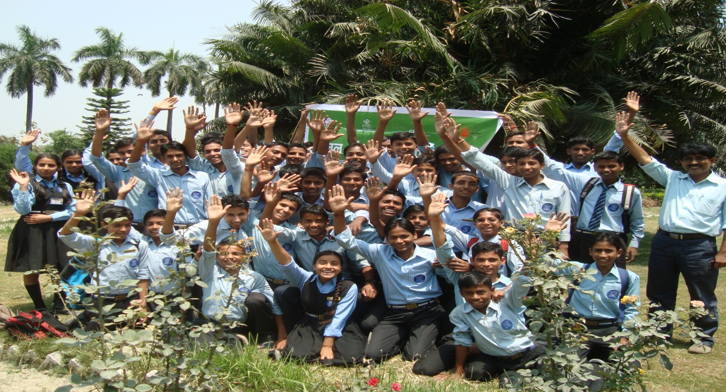

“What we are doing to the forests of the world is but a mirror reflection of what we are doing to ourselves and to one another.”
― Mahatma Gandhi

Exercise- 1. Aaoo apne Hastchap/ Hast Chinh Ko pahchane aur bada karein
(let’s increase our handprints)
Purpose: To help Eco-club students assess the impact of their environmental actions at the individual and family level, and devise ways to increase their Hand Print.
Time: 2 hours exercise and should be repeated every 2 months to help reassess the action and increase Hand Print.
Resources: Hand Print of different sizes (3 sizes)
Methodology:
- Use the attached handout and explain to the Eco club members about the hand print and discuss various indicators that can be used to assess a individual’s Hand Print in 4/5 thematic areas, that define the relative size of the handprint. Divide the eco- club members in 4 – 5 groups (each group to have not more than 8 members).
- Ask each of the members in a group to pick up the handprint size that they feel best describes their actions.
- Once each one has picked up the size that best describes his/her environmental actions ask the group to discuss why the appropriateness of choosing a size. The discussion at times may also lead to debates, as to why, a particular size is chosen by the member. The idea is to get the group members engaged in identifying environmental actions that each of them may have taken at the individual level and rank them.
- The group members can then discuss ways to increase the handprint size. Each of the group members can share how he/she plans to improve upon his /her handprint. This can become an individual log for each of the child, which can be revisited in later meetings.
- Ask the groups to meet and compare their findings and put the Hand Prints actions under the 3 categories of relative sizes.
Repeat this exercise every 6 months and record how Hand Print is changing of an individual student.
Extension/Variations: The exercise can be taken up by the eco-club members with their parents/family members to validate the results. Record the findings from the interaction.
Note: Indicative list of activities for Excercise 1 may be seen at Attachment-I

(for exercise 1)

Hand Print – Choosing lifestyles for wellbeing of life on Earth
A lot is being discussed around the world for the need to conserve environment and a lot of awareness has been generated on the actions that we need to take for wellbeing of all life forms on Earth.

Srija, a 10 years old girl in 2005 from the Holy Mary School in Hyderabad, Andhra Pradesh, India gave her handprint participating in a project, taking action for sustainability.
What is Footprint?
To make it simple to assess how we are living, what are our limits to consumption, a measure was developed in form of Footprint. Ecological footprint is a means of comparing consumption and lifestyles, and checking this against nature's ability to provide for this consumption. The tool tells us to what extent we as an individual, city, state or country are using natural resources and how much in terms of carrying capacity (limits of consumption under which the ecosystem can regenerate) that we are exceeding. The same principle is also being used to measure carbon emission and the tool is called carbon footprint.
What is Hand Print?
Hand Print is the symbol of positive actions of individuals/groups on environment just as ecological foot print is a measure of human demand on earth’s resources.
Hand Print is the measure, symbol and commitment of what we are doing or what we can do to reduce our footprints. Hand Print is a measure of our positive actions towards environment and sustainable development. It is individual and collective actions to solve the environmental problems with a belief that we can make a difference. Hand Print is a simple way to communicate to children participating in various environmental education programmes/activities and help them assess what they are doing for the environment. It is a symbol that stands for the promise for action – the very act of marking your handprint is affirmative. It can be a measure of the positive action you have taken – how much of a positive handprint are you leaving on earth.

Excercise -2

Journey from Grey to Green

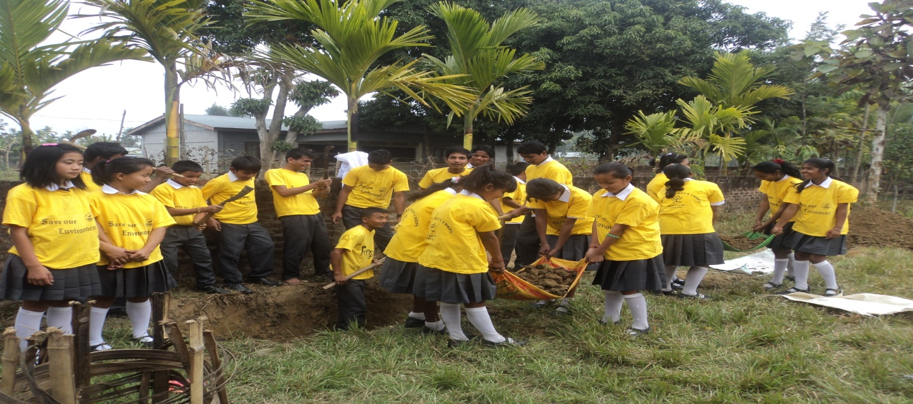
Digging Compost Pit by Govt. Middle School, Nagaland

“Come forth into the light of things,
Let Nature be your teacher”.
~William Wordsworth

Exercise- 2 Journey from Grey to Green
Purpose: The purpose of the exercise is to help the eco club to assess impact of their environmental actions on the school, and to devise ways to improve it.
Time: 2 hours and repeated on monthly basis
Material Required: Circles cut out, from colour papers (grey, brown, and green).
Process:
Explain that the idea of the exercise is to help the eco-club students /school assess how “green” is their school. Also explain that the “Green” here is to be seen not in just the plantation but in overall environmental context i.e. water, energy, waste, land, sanitation etc.
Ask the eco-club members as to what is “green school” to them, the listing can probably be clubbed in 4/5 thematic area /criteria.
Some indicators for a Green School
- Water quality
- Waste Management
- Number of plant/animal species on the campus
- Various sources of energy being used activities/actions
- Awareness of surrounding
- Learning resources on environment
For each criterion, ask them what is the indicator? give example of indicator. Like temperature is the indicator of sickness/infection. Similarly get them to talk of many other indicators from their daily life. (For ex. colour of water is indicator of its purity). List all the suggested indicators by the eco club members against the criteria.
Now divide the ecoclub members in 4/5 groups, each group handles one/two criteria. Ask them to score the indicators based on the outcome of their action against that indicator using low/medium/high score values. Also get the reasons for the score given. The student can relate to the efforts/actions they have taken to reach to the indicator of the outcome and accordingly score against the indicator.
Total the score values against each of the criterion. Share the significance of allocating colour to the scores.
Low score | Medium Score | High Score
GREY | BROWN | GREEN

Develop with the eco-club members strategy and actions that they will undertake to make grey to green journey. Present the report and strategy to SMC/Administration.
Variation: The variation of the exercise may be tried in taking up the exercise with the eco-club members, along with the school management/principal and teachers.
This will help in getting greater engagement of school teachers and the management.
Suggestive format for self assessment of the school
Criteria * | Indicator /s** | Score value  L / M /H | Reasons for the score value | Remark  (colour assigned)
A:Enhanced greenery/biodiversity | ......  ......  .......
Average score value:
B: Waste management | ........  ........
Average score value:
C: Water conservation | .........  .............
Average score value:
D: Energy conservation | .............  ..............
Average score value:
E: Sanitation | ............  ..............
Average score value:
TOTAL SCORE VALUE
* The criteria is suggestive and can be changed by the school.
**The indicator is to be listed by the eco club students with the assistance of teacher and the manual. They are free to list any indicators that they feel is important in their area/context, and could also include indicators that have bearing on social values.
Some of the suggested indicators may include
- Species richness i.e. Number of plant species, number of birds species in the school campus.
- Waste Management: Collection and segregation of waste; waste recycling and disposal – composting.
- Water Conservation: Functional rain water harvesting; no water wastage, no leaking tape, conservation messages displayed and followed.
- Energy: Use of solar energy; no energy wastage (e.g. all lights /fans switched off when not in use), Use of CFL, fuel conservation practices adopted, bus/car pool practice followed.
- Sanitation: Functional toilet facilities, safe drinking water storage, hand wash promotion and followed, waste water channelization etc.

Note: Indicative list of activities for Excercise 2 may be seen at Attachment-II
Excercise -3
Greening the neighbourhood.
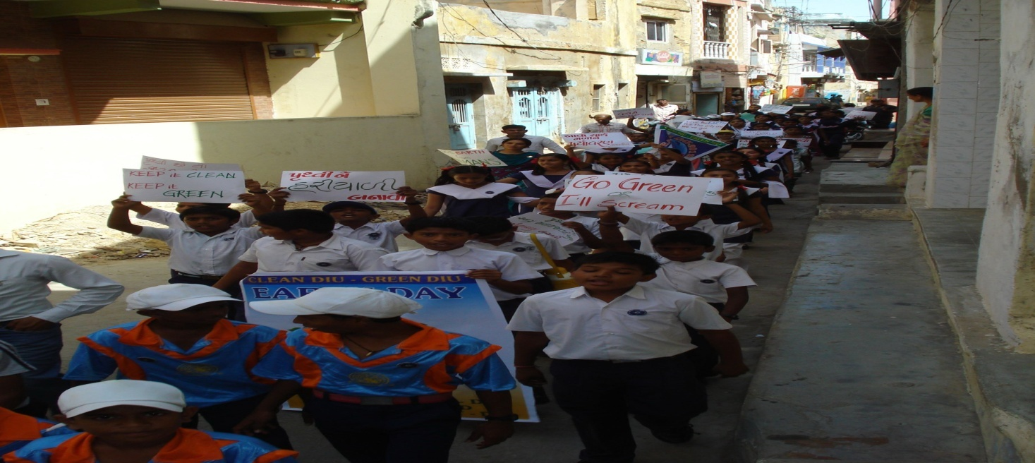
Rally by the students outside the school campus

Do not wait for leaders; do it alone, person to person. - Mother Teresa

Exercise 3: Greening the neighbourhood.
Purpose: The exercise is meant to assess outcome of actions, taken up by the eco-club students on the neighbourhood.
Time: 2 hours
Material Required: Circles cut out, from colour papers (grey, brown, and green).
Process:
Explain that the idea of the exercise is to help the eco-club members/ neighbourhood assess how “green” is their surroundings. Also explain that the “Green” here is to be seen not in just the plantation but in overall environmental context i.e. water, energy etc.
Ask the eco-club members, as to what is “green neighbourhood” to them, the listing can probably be clubbed in 4/5 thematic area /criteria.
Some indicators for a Green Neighbourhood
- Water quality
- Waste Management
- Tree Cover
- Various sources of energy being used .
For each criterion, ask them what is the indicator? give example of indicator. Like temperature is the indicator of sickness/infection. Similarly get them to talk of many other indicators from their daily life. (colour of water is indicator of its purity). List all the suggested indicators by the eco club members against the criteria.
Divide the eco-club members into groups. Ask them to score the indicators based on the outcome of their action against that indicator using a score value of Low/ Medium/ High and also get the reasons for the score value given. The eco-club members can relate to the efforts/actions they have taken against the indicator and accordingly assign score value against the indicator.
Total the score against each of the criterion. Share the significance of allocating colour to the scores.
Low score | Medium Score | High Score
GREY | BROWN | GREEN

Develop with the parents/ community members, students of neighbourhood schools , strategy and actions that they will undertake to make grey to green journey. Variation: The variation of the exercise may be tried in taking up the exercise with the parents/ community members, students of neighbourhood schools. This will help in getting greater engagement parents/ community members, students of neighbourhood.

Suggestive format for self assessment of neighbourhood .
Criteria * | Indicator /s** | Score value  L / M /H | Reasons for the score | Remark  (colour assigned)
A:Enhanced greenery/biodiversity | ......  ......  .......
Average score value:
B: Waste management | ........  ........
Average score value:
C: Water conservation | .........  .............
Average score value:
D: Energy conservation | .............  ..............
Average score value:
E: Sanitation | ............  ..............
Average score value:
TOTAL SCORE VALUE
* The criteria is suggestive and can be changed .
**The indicator is to be listed by the eco club students with the assistance of teacher and the manual. They are free to list any indicators that they feel is important in their area/context, and could also include indicators that have bearing on social values.
Note: Excercise -3 can gradually be attempted after completion of 1st and 2nd excercise.

Attachment-I
Student level indicative activity list
This manual may be taken as supportive guide in the process of self assessment based on the five thematic areas i.e. Enhanced Greenery/ Biodiversity, Waste Management, Water Conservation, Energy Conservation, Sanitation.
Thematic Area | Indicative Individual Level activities to assess your handprint
Enhanced Greenery/ Biodiversity | 1. Recognised the local species and planted it in my home garden/ or in pot at my rooftop etc.  2. Placed water bowl on my roof top for birds, squirrels etc.
Waste Management | 1. Carry my own shopping bag.  2. Made a magazine holder from waste cloths and plastic sheets.
Water Conservation | 1. Reported about leaky pipes to school staff/house owner/parents.  2. Collected the water used at home for rinsing the fruit and vegetables and used it to water house plants.
Energy Conservation | 1. Turn off Lights when not in use  2. Turn off entertainment devices when not in use
Sanitation | 1. Regularly clean my hands before eating.  2. Report about dirty toilet to my school staff/teachers/ parents.
Students while filling up the individual activities may take note of following points:
1. At one time only one thematic area can be chosen.
2. Two activities given against each thematic area will appear as default activities in hand print selection menu of the portal.
3. You may write down other 8 activities including the two suggested by us or may add two more activities in the drop down space against each thematic area.
4. After submitting the number of activities given by you a automated size of hand print will be allotted to you.
5. Scoring on scale of 10 activities may be defined as :
1-3 activities – Small Handprint, 4-6- Medium Hand Print, 7-10 Large Hand Print.

Attachment-II
Eco Club level indicative activity list
This manual may be taken as supportive guide in the process of self assessment based on the five thematic areas i.e. Enhanced Greenery/ Biodiversity, Waste Management, Water Conservation, Energy Conservation, Sanitation.
Thematic Area | School level activities to rate the colour for school.
Enhanced Greenery/ Biodiversity | 1. Special instructions to school gardener to plant different species of plants in school garden  2. Shady trees on the path sides of school campus.
Waste Management | 1. Provisions of dustbins outside the every classroom.  2. Ban for plastic bags inside school premises.
Water Conservation | 1. Sprinklers for watering trees and plants in garden.  2. Provisions for utilising waste water of common drinking facility for planting trees.
Energy Conservation | 1. Replaced incandescent lamps with CFL.  2. Maximum use of natural daylight especially in the classrooms having windows at the outer wall.
Sanitation | 1. Clean toilets.  2. Routinely check the nails and cleanliness of students.
Teacher In charge while filling up the activities may take note of following points:
1. At one time only one thematic area can be chosen.
2. Two activities given against each thematic area will appear as default activities in colour selection menu of the portal.
3. You may write down other 8 activities including the two suggested by us or may add two more activities in the drop down space against each thematic area.
4. After submitting the number of activities given by you a automated colour will be allotted to you.
5. Scoring on scale of 10 activities may be defined as :
1-3 Activities – Grey Colour, 4-6- Brown, 7-10 Green.

Attachment -III

Annual Report Format for NGC School
This annual report is to be submitted to the District Implementation and Monitoring Committee (DIMC) along with the Statement of Expenditure given in Annexure- I.
- Details of the NGC school:

Name of the School and Principal
Strength/Enrolment of the school (Boys, Girls)
Medium of instruction
Complete postal address (with e-mail, phone number etc.)

- About NGC programme
- Name of the teacher in-charge/coordinator:
- Participation of coordinator in orientation/training programme (yes/no, if yes date):
- Name of Eco club and date of eco- club formation:
- Number of students in Eco club: Boys: Girls: Total:

- Details on eco club activities
- Number of eco club meetings held and frequency (Daily/Weekly/Fortnightly/Monthly/Others):

4A: (This is only an indicative list, the NGC schools/eco-clubs may as well develop

innovative activities at their own level)
Activity
Level 1 – Awareness activity | Date and Duration | No. of participating students
Rally
Film shows
Expert Talks
Street play
Nature camp/Nature walk
Exhibition
Others including important events
Level 2 – Observation and Documentation
Survey Outings
Data Collection
Record Keeping
Analysis
Presentation
Others
Level 3- Action Projects
Plantation
Vermicomposting/composting
Sanitation facility
Water conservation
Energy saving measures
Others

4B: Reporting On Outcomes
Levels | Number of Students/Families in Neighbourhood/Society showing |  |  | Remarks
 | Small hand Print | Medium Hand Print | Large Hand Print
Individual (Students)
 | Grey Colour | Brown Colour | Green Colour
Schools
Neighbourhood

Annexure - I
NGC Grant received: Amount: Date:
Grant from Other Agency:
 | Amount | Date
State Govt.
Corporates
NGOs
Resource /Education materials received:
Yes/No | Type | Nature of adequacy of Resource material

S. No. | Activities/tasks | Amount Spent
1 | Administrative costs
2 | Activity costs
3 | IEC material costs
4 | Other costs
5 | Total

Signature of the In-Charge teacher:
Signature of the Head Master/Principal with seal:
Date:
City/Town/Village:

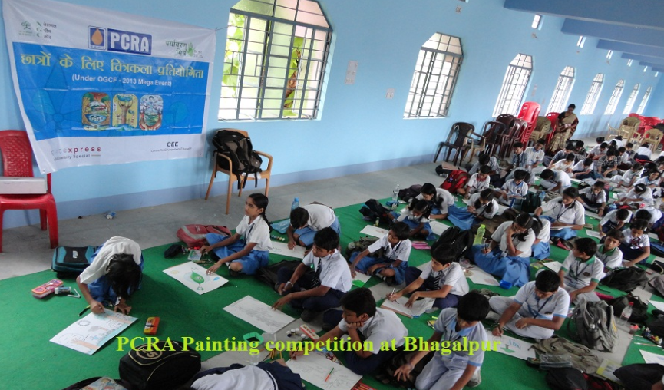

Contact Us

Ministry of Environment, Forests and Climate Change
Environment Education Division,
Agni Wing, 2nd Floor
Indira Paryavaran Bhavan
Ali Ganj, Jor Bagh Road
New Delhi- 110003
Email : nationalgreencorps@gmail.com

***************************************************************************************************************
****************************************************************************************************************

