
REGENERATION AND DEVELOPMENT
[National River Conservation Directorate, Ganga Action Plan Phase I, Other major River Action Plans, Yamuna Action Plan, Gomti Action Plan, Damodar Action Plan, Ganga Action Plan - Main Stem, Works in other Rivers under the NRCP, National River Conservation Authority, National Lake Conservation Plan, National Afforestation & Eco-Development Board, National Afforestation Programme through Community Participation, Grants-in-aid for Voluntary Agencies, Monitoring and Evaluation, Regional Centres, National Action Plan to Combat Desertification]

National River Conservation Directorate
The National River Conservation Directorate (NRCD) functioning under the Ministry of Environment and Forests is engaged in implementing the River Action Plan under the National River Conservation Plan (NRCP) by providing assistance to the State Governments. The objective of NRCP is to improve the water quality of the rivers, which are the major fresh water sources in the country, through the implementation of pollution abatement schemes. So far a total of 31 rivers have been covered under the programme. The rivers are in Table-17.

Table – 17
The rivers covered under pollution abatement schemes
S.No River S.No River S.No River S.No River
1. Adyar 9. Ganga 17 Musi 25 Tunga
2. Betwa 10. Godavari 18 Narmada 26 Tungabadra
3. Bhadra 11. Gomati 19 Pennar 27 Tamarabarni 4. Brahmani 12. Khan 20 Pamba 28 Vaigai
5. Cauvery 13. Krishna 21 Sabarmati 29 Vennar
6. Cooum 14. Kshipra 22 Satluj 30 Wainganga
7. .Chambal 15. Mahanadi 23 Subarnarekha 31 Yamuna
8. Damodar 16. Mandovi 24 Tapti

The important works being taken up under the NRCP include:
– Interception and diversion works to capture the raw sewage flowing into the river through open drains and divert them for treatment.
– Sewage Treatment Plants for treating the diverted sewage.
– Low Cost sanitation works to prevent open defecation on riverbanks.
– Electric crematoria and Improved Wood Crematoria to conserve the use of wood and help in ensuring proper cremation of bodies brought to the burning ghats.
– River Front Development works such as improvement of bathing ghats.
Ganga Action Plan Phase-I (GAP-I)
The first River Action Plan to be taken up under the NRCD was the Ganga Action Plan. The objective of the GAP Phase-I was to improve the water quality of the river Ganga. The action plan primarily addressed itself to the interception and diversion for treatment of 873 million litres per day (MLD) of municipal sewage in 25 towns .GAP Phase-I scheme has been closed on 31st March 2000. A sewage treatment capacity of 865 MLD has been created under the programme and an amount of about Rs. 452 crore has been spent. The water quality of river Ganga is being monitored at 27 locations from Rishikesh in Uttaranchal to Uluberia in West Bengal by institutions such as Bharat Heavy Electricals Limited (BHEL); Haridwar, CPCB Zonal Office, Indian Institute of Technology; Kanpur, Patna University and Bidhan Chandra Krishi Vishwavidyalaya, Kalyani. As a result of the schemes completed under GAP Phase-I, the water quality of river Ganga shows a general improvement. The summer average values of two important river water quality parameters viz. Dissolved Oxygen (DO) and Biochemical Oxygen Demand (BOD) for some of the important monitoring stations on river Ganga is given in Table-18.
Table – 18
* Summer Average Values for Water Quality on Main Stem of River Ganga under Ganga Action Plan

Station Name Distance in Km Dissolved Oxygen Biochemical (mg/l) Oxygen Demand (mg/l)
1986 2002 2003 1986 2002 2003
Rishikesh 0 8.1 8.30 8.1 1.7 1.10 0.5
Hardwar D/S 30 8.1 7.90 8.1 1.8 1.60 0.8
Garhmutkeshwar 175 7.8 - 7.8 2.2 - 1.2
Kannauj U/S 430 7.2 7.65 7.2 5.5 1.17 1.2
Kannauj D/S 433 NA 6.50 NA NA 4.23 3.3
Kanpur U/S 530 7.2 6.27 7.2 7.2 3.80 3.7
Kanpur D/S 548 6.7 6.75 6.7 8.6 4.90 6.1
Allahabad U/S 733 6.4 13.00 6.4 11.4 - 4.8
Allahabad D/S 743 6.6 8.20 6.6 15.5 3.80 3.2
Varanasi U/S 908 5.6 10.80 5.6 10.1 3.00 2.5
Varanasi D/S 916 5.9 7.50 5.9 10.6 2.50 5.4
Patna U/S 1188 8.4 7.08 8.4 2.0 1.88 2.0
Patna D/S 1198 8.1 7.10 8.1 2.2 1.95 2.8
Rajmahal 1508 7.8 7.93 7.8 1.8 1.48 2.2
Palta 2050 NA 7.25 NA NA 2.66 2.2
Uluberia 2500 NA 5.43 NA NA 1.94 1.9
* Mean value for the months of March to June when the temperatures are high and flows are low.
NA – Data not available
U/S - Upstream
D/S- Downstream
Mg/l-miligram per litre

Other major river Action Plans
The Ganga Action Plan model with necessary corrections has been applied to the polluted major rivers of the country under the National River Conservation Plan (NRCP). Since Ganga Action Plan Phase-I did not cover the pollution load of Ganga fully, the 2nd Phase of Ganga Action Plan which covers its tributaries Yamuna, Gomti and Damodar besides river Ganga itself was launched and approved in stages between 1993 and 1996 for implementation. Simultaneously, the NRCP was also launched in 1995 to cover other major rivers in the country. The present approved cost of NRCP as a whole stands at Rs. 4492 crore (excluding CETP Kolkata, Establishment & R&D) covering pollution abatement works in 157 towns along polluted stretches of 31 rivers spread over 18 States. The river wise details of all the 157 towns of NRCP are given at Annexure-III.

Yamuna Action Plan (YAP)
The Yamuna Action Plan (YAP) presently covers pollution abatement works in 21 towns. The approved cost of YAP is Rs. 509.45 crore of which an expenditure by the states of Rs. 474.57 crore has been incurred so far. A treatment capacity of 738 million litres per day (MLD) has been created. Of the 179 schemes of pollution abatement sanctioned under Yamuna Action Plan, 161 schemes have been completed. Additional pollution abatement works in 15 towns of short gestation period amounting to Rs. 222.60 crore were approved in May 2001. All the works have been completed under this package.
Government of India, Ministry of Environment and Forests have received financial assistance of Yen 13.33 billion from the Japan Bank for International Cooperation for implementation of Yamuna Action Plan (YAP) Phase II, which is part of the National River Conservation Plan (NRCP).
The loan agreement between Government of Japan and Government of India has been signed on 31st March, 2003. The project has been approved by CCEA at an estimated cost of Rs. 624 crore for abatement of pollution of river Yamuna in Delhi, UP (9 towns) and Haryana (8 towns) under YAP-II.
The cost of works under YAP-II is to be shared between Government of India and State Governments in the ratio of 85:15 i.e. Rs. 530 crore central share and Rs. 94 crore state’s share.
The main components to be implemented under the project are:
Delhi - STP (135 mld capacity new and 324 mld capacity rehabilitation)
Rehabilitation/replacement of trunk sewers (30.82 kms)
UP - STP (38 mld capacity new)
Sewer lines (73 kms)
Rising Main (12.7 kms)
Haryana - Sewer lines (73 kms) and improvements in efficiencies of existing STPs.
YAP-II project also includes preparation of DPRs for projects in the 3 States which are proposed to be undertaken under YAP-III with JBIC assistance. Emphasis has also been given on public participation, capacity building etc. in order to ensure better utilisation of assets and long term sustainability of the project.

Gomti Action Plan
Financial sanction for the 2nd phase of Gomti Action Plan at Lucknow has also been accorded in June, 2003 for Rs.263.04 crore. The project cost is to be shared in the ratio of 70:30 between GOI and state government. The works in this phase will include two sewage treatment plants of a total capacity of 375 MLD (over and above the 42 MLD capacity being set up in the first phase), interception & diversion works of sewage of the remaining drains and other miscellaneous items such as river front development, toilets, plantation, public awareness and participation and acquisition. At present tendering of some of the components of the project is on.

Damodar Action Plan
Under this Action Plan, pollution abatement works at a cost of Rs. 23.58 crore are being taken up in 12 towns. Of these 8 are in Jharkhand and 4 in West Bengal. So far 11 schemes have been sanctioned.
Ganga Action Plan - Main Stem
Pollution abatement works are also being taken up in 59 towns along the main stem of river Ganga at an approved cost of Rs. 682.11 crore. Of these 10 towns are in Uttaranchal, 12 in U.P, 14 in Bihar and 23 in West Bengal.

Works in Other Rivers under the National River Conservation Plan
In addition to the works being taken up for pollution abatement of river Ganga and its tributaries, pollution abatement works are also being taken up in 62 towns along 27 major rivers in 12 States of the country.
Out of 308 schemes of pollution abatement sanctioned under this Action Plan so far, 129 schemes have been completed. About 3054 million litres per day (MLD) of sewage is targeted to be intercepted, diverted and treated. Out of the approved cost of Rs 2271.66 crore, the expenditure incurred by States amount to Rs. 632.30 crore.
Details of Projects Approved/Completed
The list of projects sanctioned between 1.4.2002 to 31.3.2004 are given in Annexure-IV. Details of projects completed between 1.4.2002 to 31.1.2004 are given in Annexure-V.

Water Quality Management Plan for River Ganga
The Japan International Cooperation Agency (JICA) is providing technical assistance for taking up a study on ‘Water Quality Management Plan for river Ganga’. The objective of the study is to (i) formulate the Master Plan for water quality management for the Ganga basin concerning liquid waste and (ii) formulate feasibility studies for high priority projects (basically sewerage and sewage treatment) identified in the Master Plan focusing on four towns namely Kanpur, Allahabad, Varanasi and Lucknow. The study has been started in March 2003 and will be completed in a period of 2 years.
Standards
Based on the design criteria for sewage treatment plants the environmental standards followed by NRCD for treated waste water are:
BOD - 30 mg/litre
TSS - 50 mg/litre
Keeping in view the interest of public health, an expert group has reviewed the water and wastewater standards with special reference to the levels of microbial load and made the microbial standards in water and treated wastewater stricter. The revised standards for microbial quality are:
(i) River water quality - Fecal coliform count of
standards for bathing MPN 500 per 100 ml
class (Desirable)
MPN 2500 per 100 ml
(Max. permissible)
Fecal Streptococci : 100
per 100 ml (Desirable)
500 per 100 ml (Max.
permissible)
(ii) Treated wastewater - Fecal coliform count of
(for Irrigation) MPN 1000 per 100 ml
(desirable)
MPN 10,000 per 100 ml
(max. permissible)
Industrial Pollution Control
The National River Conservation Authority (NRCA) in its meeting held on July 12, 1997 under the chairmanship of the Prime Minister, decided that the polluting industries which are directly discharging their effluents into rivers and lakes, without requisite treatment, should be asked to install the requisite effluent treatment systems within three months, failing which closure notices should be issued. The criteria defined for the National River Conservation Plan (NRCP) was followed and the identified industries include those which (i) discharge their effluents into a water course including rivers and lakes and (ii) are either involved of hazardous substances or discharge effluents with a BOD of 100 kilograms/day or more, or both. A total of 851 defaulting units were identified in August 1997 and they were issued directions to comply with the standards and install effluent treatment plant whenever required. As on 30.9.2003, 608 units have complied with the direction, 238 were closed. The Statewise details are given in Table-19.

Table – 19

Summary Status of Pollution Control in Grossly Polluting Industries discharging their effluents into Rivers and Lakes (as on Sept. 30, 2003)
S.No Name of the State Total No. No. of No. of units which have No. of /Union Territory of Units UnitsClosed provided requisite treatment defaul
/ disposal facilities after ing units issuance of directions
1. Andhra Pradesh 60 18 42 00
2. Assam 07 06 01 00

3. Bihar 14 04 10 00
4. Gujarat 17 03 14 00
5. Haryana 21 09 12 00
6. Karnataka 20 02 18 00
7. Kerala 36 04 32 00
8. Madhya Pradesh 02 01 00 01
9. Maharashtra 06 03 03 00
10. Orissa 09 03 04 02
11. Pondicherry 04 00 04 00
12. Punjab 18 01 16 01
13. Tamil Nadu 366 118 248 00
14. Uttar Pradesh 241 59 181 01
15. West Bengal 30 07 23 00
Total 851 238 608 05

National River Conservation Authority
The National River Conservation Authority under the chairmanship of Hon’ble Prime Minister met on 16th June, 2003. The Authority reviewed the implementation of the programmes, identified the shortfalls and discussed the remedial measures. After deliberations the Authority agreed upon the following:
– Major thrust and impetus has to be given to cleaning of major rivers as a part of national and state level strategy. Thrust will be given to the components such as internal sewers, solid waste management. so as to optimise the impact in terms of quality parameters.
– The State Government shall initiate action to ensure that the O & M costs are provided commensurate with the requirements. They may also take steps for augmentation of resources for maintaining assets through amalgam of strategies like taxation, sale of treated water, deployment of assets for revenue raising, privatisation of maintenance facilities. State governments may also approach their State Finance Commission to earmark funds for operation and maintenance of assets. The 12th Finance Commission will be approached to consider earmarking funds for maintenance of assets through devolution process.
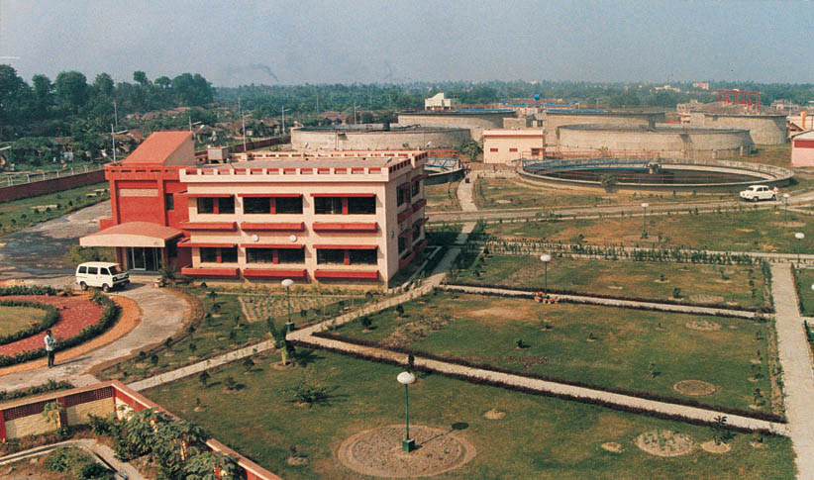
Fig 57. 40 MLD Sewage Treatment Plant at Baranagar - Kamarhati, West Bengal
– The institutional arrangement will be strengthened and monitoring and evaluation methods will be sharpened to keep a close watch on the schemes to ensure timely execution of the projects and to maintain the quality parameters.
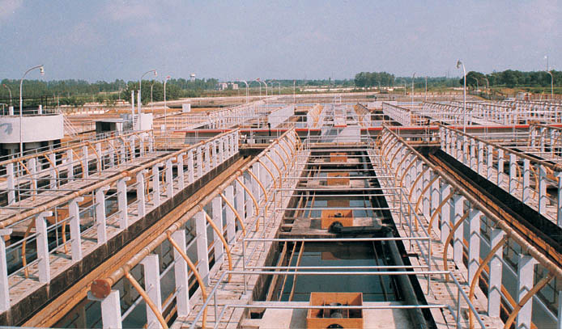
Fig 58. Reactors Sewage Treatment Plant, Saharanpur

National Lake Conservation Plan
Government of India under National Lake Conservation Plan (NLCP) approved a programme for conservation and management of polluted lakes in May 2001. The objective of the scheme is to restore and conserve polluted and degraded lakes and other similar bodies.During the year 2002-2003 following projects were approved: 4 lakes in Bangalore namely; Vengaihnakere, Kamakshipalya, Jarganhalli and Nagavara, Mansagar Lake in Jaipur, Rabindra Sarovar in Kolkata, 9 lakes of Thane district in Maharashtra, Bellandur and Kotekere in Karnataka. In 2003-2004, 5 lakes in Nainital district including Nainital Lake in Uttaranchal and Bhishma in Karnataka was approved. The funding pattern under NLCP was revised to 70:30 cost sharing between central and the state government with effect from January 2002. The total cost of the approved projects is Rs. 139.93 crores.
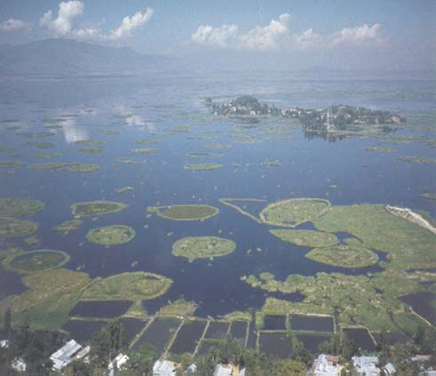
Fig 59. Loktak Lake in Manipur
National Afforestation and Eco-Development Board
The National Afforestation and Eco-Development Board (NAEB) was set up in August 1992 for promoting afforestation, tree planting, ecological restoration and eco-development activities in the country. Special attention is being given to the regeneration of degraded forest areas and lands adjoining forest areas, national parks, sanctuaries and other protected areas as well as the ecologically fragile areas like the Western Himalayas, Aravallis, Western Ghats, etc. The roles and functions of NAEB are:
– Evolve mechanisms for ecological restoration of degraded forest areas and adjoining lands through systematic planning and implementation, in a cost effective manner;
– Restore through natural regeneration or appropriate intervention the forest cover in the country for ecological security and to meet the fuel wood, fodder and other needs of the rural communities.

Fig 60. A view of Nainital Lake
– Restore fuelwood, fodder, timber and other forest produce on the degraded forest and adjoining lands in order to meet the demands for these items;
– Sponsor research and extension of research findings to disseminate new and proper technologies for the regeneration and development of degraded forest areas and adjoining lands;
– Create general awareness and help foster a people’s movement for promoting afforestation and eco development with the assistance of voluntary agencies, non-government organizations, Panchayati Raj institutions and others and promote participatory and sustainable management of degraded forest areas and adjoining lands;
– Coordinate and monitor the action plans for tree planting, ecological restoration and eco development; and
– Undertake all other measures necessary for promoting afforestation, tree planting, ecological restoration and eco development activities in the country.
The Board of NAEB is broad based with Minister of Environment and Forests as chairperson, and member representatives of central government ministries, state governments, eminent persons in this field and NGOs. It sets broad directions for the works of NAEB. The last meeting of the Board, which is the 9th so far, was held on 22nd October,2003 to mainly discuss suitable interventions by government and NGOs to achieve the X-Plan goal of increasing the national forest and tree cover to 25% of the geographical area by 2007 and 33% by the year 2012. The composition of board was further broadened by inclusion of Secretary, Ministry of Water Resources as a member.
The major schemes under implementation during the Tenth Plan period are as under:-
National Afforestation Programme through Community participation
Keeping in view the objective of achieving 25% tree/forest cover as part of the monitorable target set out for the Tenth Five Year Plan, the Ministry has launched a very ambitious afforestation programme with people’s involvement for the sustainable management of the country’s forests. Under this programme, all afforestation schemes of the Ministry have been brought under a single National Afforestation Programme being implemented through decentralized Forest Development Agencies (FDA) set up at the forest division level. The FDAs are a confederation of Joint Forest management Committees (JFMCs) at the village level to provide an organic link between the forest departments and the grass-root level communities.
During the Tenth plan, an amount of Rs. 1264.44 crore is earmarked which will, apart from generating gainful employment, create community assets for meeting the requirement of fuelwood, fodder and small timber.
As many as 515 NAP projects have been sanctioned so far with a physical target of treating 7,61,206 ha land. An amount of Rs. 426.96 crore has already been released during 2002-03 and 2003-04. Out of these 92 projects with an outlay of Rs. 225.41 crore have been sanctioned for the North Eastern States for the 10th Plan treating an area of 1,41,798 ha. An amount of Rs. 77.44 crore has been released during 2002-03 and 2003-04. Out of these 92 projects 14 projects are being implemented for jhum (shifting cultivation) land rehabilitation.
An amount of Rs 230.00 crore is proposed for 2004-05 out of which Rs 40.00 crore is for north-eastern states under the NAP scheme.
Grants-in-aid for Voluntary Agencies
To encourage local communities in tree planting activities, financial assistance to Non-Government Organization (NGOs)/Voluntary Agencies (VAs) are continued to be given under this ongoing scheme.
During the Tenth Five Year Plan, all project proposals are required to be forwarded by the office of State Principal Chief Conservator of Forests after thorough scrutiny and appraisal.
During the year, about 177 new projects have been sanctioned of which 94 projects are for the North eastern region and 83 projects for the rest of India. In all at present there are 129 projects running in the N E region with an outlay of Rs. 2.49 crore. In the rest of India there are a total of 123 projects in operation with an outlay of Rs. 4.00 crore.

Monitoring and Evaluation (M&E)
All projects and schemes of NAEB are subject to close monitoring by implementing agencies, and concurrent and final evaluations by independent evaluators. In addition, NAEB gets sample checks conducted for plantations under 20 Point Economic Programme in 50 sample districts each year by independent agencies. The monitoring, evaluation and sample check reports are very good tools for assessing the performance of different projects run by NAEB and how these could be best implemented or modified to achieve our national objectives and goals. All current schemes in the Tenth Plan are designed based on the monitoring and evaluation reports of the Ninth Plan schemes which clearly indicated that there is a need for broad-based people’s participation for the success and for this suitable people’s institutions are necessary. As a result the institution of Forest Development Agency (FDA), which is a forest division-level federation of village forest committees, has been formalized and supported under the National Afforestation Programme (NAP) of NAEB in the Tenth Plan. The initial monitoring reports of NAP assisted FDAs are highly encouraging so that it has been decided to extend NAP support to all possible 814 FDAs in the country.
In addition to M&E being used as a long term planning tool, it also helps in remedying obvious weaknesses or discrepancies during the implementation of NAEB projects and 20 Point Programme plantations by various implementation agencies. A copy of such M&E reports is sent to the respective state government, district official and implementing agency with specific recommendations by NAEB for taking necessary remedial measures, if required.
In general, the Monitoring and Evaluation (M&E) reports have revealed that:
– People’s participation in various programme is evolving satisfactorily.
– There is some concern about timely implementations due to delay in transfer of funds to front line staff or agency.
– Species for planting are being chosen as per local conditions, and people’s participation in this activity is increasing.
– Creation of community assets under Entry Point Activity (EPA) component of various projects goes a long way in improving livelihoods of the local people and in developing enduring partnerships with local people.
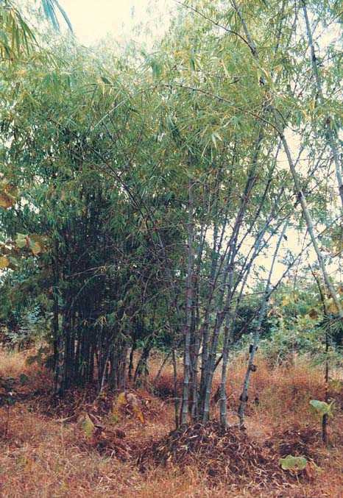
Fig 61. Growth of bamboo culms after cleaning and soil working
In addition to regular M&E work, NAEB has launched the following in the current financial year:
– Final evaluation of selected AOFFP, NTFP & IAEP projects (implemented in Ninth Plan) has been launched through independent agencies/experts
– National level JFM study has been launched during the year 2003-04.
– Forest Survey of India, Dehradun has been assigned the task of monitoring of area/forest cover in selected 60 FDAs each year for a period of three years.
Regional Centres
The Board has seven Regional Centres (RCs) located in Universities/National level Institutions (Annexure II). These Centres help NAEB in promoting extension of replicable technologies and for dissemination of research findings. They provide technical and extension support to the State Forest Department in preparing projects for regeneration of degraded forests and adjoining lands with people’s participation, and also act as a forum for the exchange ideas and experiences amongst the States of the region as well across the regions. In addition, these centers carry out problem-specific studies as well as evaluation of NAEB’s programmes in the field, and organize training programmes and workshops.
During the year, the RCs conducted a number of training programmes on Joint Forest management (JFM), interactive workshop on forestry programmes, micro-planning exercise, etc wherein representatives of State Forest Departments and NGOs participated. The centres also conducted problem specific studies as per the request of State Forest Department. The Regional Centres have been entrusted the task of undertaking training need assessment for various stakeholders (forest department staff and JFMCs, FDA members).
During 2003-04, an amount of Rs. 1.80 crore had been released to regional centres. For the year 2004-05 an amount of Rs. 2.30 has been proposed for the Scheme.
Communication
New technologies and methodologies of participatory management, eco-development and regeneration of degraded forests are being progressively developed. In order to share such experiences and technologies widely, NAEB documents such developments and information and brings out publications, makes films and shares these with state governments, NGOs and all those concerned with these issues.
An awareness campaign was launched through Vigyan Rail during the year 2003-04. On the eve of World Desertification Day on June 17, an advertisement was released to generate popular awareness.
Professional and Special Services
The National Afforestation and Eco-Development Board takes up special studies of important issues relating to policy formulation, programme implementation, etc. The Board also engages special consultants for taking up a variety of assignments. During the year the following studies have been launched through independent consultant:
– Preparation of Micro Mission on Bamboo Resource Development by Forest Survey of India.
– Preparation of Micro Mission on Bio fuel by Arid Forest Research Institute, Jodhpur.
– Preparation of compendium on Sample Checks of selected districts during Ninth Plan by Agriculture Finance Corporation, New Delhi.
Eco-Task Forces
Eco-Task Force is an on-going scheme. Ecological Task Forces (ETFs) of ex-servicemen are employed in remote and difficult areas to undertake restoration of degraded ecosystems through afforestation, soil conservation and water resource management techniques. At present there are four Eco-Task force battalions operating in the states of Uttaranchal (two), Rajasthan (one) and Jammu & Kashmir (one).
During the year 2003-04 an amount of Rs. 9.94 crore was released for the scheme. The provision of the scheme for the year 2004-05 is Rs. 8.00 crore for maintaining the four battalions already raised.
National Action Programme to Combat Desertification
India is a party to the UN Convention to Combat Desertification (UNCCD) and Ministry is the National Coordinating Agency for the implementation of the UNCCD in the country. As an affected party, a comprehensive National Action Programme (NAP) to combat desertification in the country has been prepared. The objectives are:-
– Community based approach to development;
– Activities to improve the quality of life of the local communities;
– Awareness raising;
– Drought management preparedness and mitigation;
– R & D initiatives and interventions which are locally suited;
– Strengthening self Governance leading to empowerment of local communities.
For the Tenth Five Year Plan, it is proposed to initiate activities that include, among others, assessment and mapping of land degradation, drought monitoring and early warning system groups, drought preparedness contingency plans, and on-farm research activities for development of indigenous technology.
World Day to Combat Desertification was celebrated on June, 17, 2003, throughout the country.
Under UNCCD, a Regional Action Programme for Asian countries has been formulated to strengthen the existing capacity of the parties and to network each other for effective measures to combat desertification. The following six Thematic Programme Network (TPN) have been identified for this purpose.
TPN-1 : Desertification Monitoring & Assessment
TPN-2 : Agro-forestry and Soil Conservation in Arid, Semi-arid and Dry Sub-humid Areas
TPN-3 : Range and Pasture Management in arid areas with particular emphasis in controlling and shifting sand dunes.
TPN-4 : Water Resources Management for Agriculture in Arid, Semi-arid and Dry Sub-humid Areas
TPN-5 : Drought Preparedness and Mitigation in the Context of Climate Change
TPN-6 : Strengthening Planning Capacities for Drought Management and Controlling Desertification
India is the host country for TPN-2 “Agro-forestry and Soil Conservation in Arid, Semi-arid and Dry Sub-humid Areas.” The Central Arid Zone Research Institute (CAZRI), Jodhpur has been identified as National Task Manager. In order to create an information network on TPN-2 an interactive website has been hosted by CAZRI w.e.f. August, 2002 at http://cazri.raj.nic.in. During the year, Asian Regional Agro-forestry workshop was held on 17-20 December, 2003 at Bangalore. It was decided to prepare a draft manual on best practices in Agro-forestry in Asian region.
Asian Regional Ministerial Conference in preparation of COP-6 meeting was held at Abu-Dhabi on 3rd June, 2003. India had participated in the said consultation. The conference followed by the Asian Focal Point Meeting adopted the Regional Action Programme 2002-03 to 2007-08.
India has participated in COP-6 meeting of UNCCD held at Havana from 22nd August to 3rd September, 2003. The following decisions have been taken in the COP-6 meeting:-
– Global Environment Facility (GEF) has been adopted as one of the financial mechanism of UNCCD.
– Adopt and prioritize forest resources assessment techniques for effective analysis of the status of land cover.
– Invites the appropriate institutions to undertake a comprehensive study on the cost of inaction and to share this at COP-7.
– Adopt and enhance policy measures and incentive schemes to encourage private-sector support for technological and scientific cooperation benefiting the drylands.
– Implement programmes of the UNCCD relevant to rehabilitation of degraded lands, renewable source of energy as well as integrated water resource management and mountain eco system preservation.
– Encourages parties to develop, test and use appropriate benchmarks and indicators, especially those, which target the local level and the involvement of civil society.
India has participated in launch meeting of TPN-5 Drought Preparedness and Mitigation in the Context of Climate Change held at Ullan Bator, on 17th July, 2003.
A National Consultation workshop on cost of land Degradation/Desertification in India was held on 23-24 March, 2004 at New Delhi in collaboration with Institute of Economic Growth, University of Delhi. The workshop deliberated on the broad framework of assessment of the economic cost of land degradation.
Similarly, India is participating actively in TPN-1 “Desertification Monitoring and Assessment”. A pilot project on Desertification Status monitoring is under progress through the Indian Space Research Organisation (ISRO), Space Application Center, Ahmedabad at a cost of Rs. 1.39 crore. Space Application Centre has compiled the data and developed Bio Physical indicator for land degradation in India. India has also joined the TPN-4 “Water Resources management for Agriculture in Arid, Semi-arid and Dry Sub-humid Areas”. The Ministry of Water Resources has been identified as National Task Manager for TPN-4. India has been selected as lead country on the working group “Traditional knowledge” under TPN-3.

