ERRAGUDUR VILLAGE NOW ON ECO - FRIENDLY

**MODEL VILLAGE IN ANDHRA PRADESH , INDIA**

______________________________________________

In 1992 started social voluntary organization of P.S.S. Educational Development society (NGO) and inaugurated a eco friendly model Erragudur village of Pamulapadu Mandal Kurnool District of Andhra Pradesh that was worked and Heavy blasting by Telugu Ganga Project work in 2009. The village lives in Erragudur Grama Panchayat and has been built under the take Relief and Rehabitation programme by P.S.S Educational development plants planted within Erragudur village.PSS.Educational Development society (NGO) and Blue cross youth seva sangam Executive Secretary Bathula Sanjeevarayudu erragudur is located beside of Telugu ganga project & Pothureddy padu project of Kurnool District of Andhra Pradesh. The Housing and social infrastructure was by P.S.S Educational Development Society and Blue Cross (NGO) of many verities of trees planted, Trees reverse the impacts of land degradation and provide food, energy and income, helping communities achieve long-term economic and environmental sustainability. Trees also filter the air and help stave off the effects of climate change.  In just one year, a mature leafy tree produces as much oxygen as 10 people inhale! , **VALUES The organization believe in the following values,Transparence,Accountability,Discipline,Respect,Honest and trust,Unity** With the Govt support the rehabilitation and reconstruction activities in Erragudur village Gram Panchayat located in the remotest parts of Nallamalla Forests has little external connectivity’s linkage, electricity, drinking water supply sanitation, special schools of ST Sugali (Banjara), internal roads and is prove to frequent natural disaster. This development was conceptualized, planned and implemented by PSS Educational Development Society and Blue Cross Youth Seva Sangam (NGO) as an Eco – friendly model village with aim to transform the life style of the effected community and narrow the gap between the privileged and under privileged sections of the society. PSS Educational Development society and Blue cross youth seva sangam (NGO) B.Sanjeevarayudu under took a holistic planning approach and use innovative themes and ideas while drawing up this village. Pothureddy padu project widening of work used heavy blasting by contract company. 574 houses fully damaged by heavy blasting. The NGO Team ensured full involvement of the affected communities by beneficiaries during the entire cycle of development & welfare of process. It took and provided facilities and amenities such as drinking water supply, sanitation, amenity building, cattle sheds, machaans, (raised resting plat forms). Shade net, green house, adequate open areas including children play areas, space for communities participation, besides creating disaster resistant dwelling unitis, Animal welfare & Development, The NGO team under B.Sanjeevarayudu ensured full involvement of the affected people and beneficiaries during the entire cycle of development process several green and eco efficience features. Were in corporate in planning, design and contruction. Collection and treatment of Solid Waste in the Village, Sewage/ Liquid Waste treatment and its reuse, Improved accessibility of road transport to increase personal mobility and agriculture production , Cost effective approach to Street lighting for road safety and reduction in crime after dark , Ways to improve healthcare services in village, Facilitating Digital Literacy at Village level to bridge digital divide in the country, Creating Employment Opportunities and amenities for Rural Youth , Facilities and infrastructure for women in Rural

Additionally PSS Educational Development Society & Blue Cross Youth Seva Sangham (NGO) ensured extensive usage of locally available materials, skill sets and employed the local work force in this project. Erragudur village most back word and heavy blasting effected village a year ago, now erragudur village to day has been completely transformed and boasts of a clean environment good ambience and safe living with all facilities like water supply, sanitation, greenery amenity buildings, lighting, Education, Health, Banking, formation of womenself help groups, A.P. Government all programmes implementation, linkage roads with other villages good implementation of MNREGS Programme Animal welfare etc., NGO Executive Secretary Bathula Sanjeevarayudu take special efforts and concentration dedicatedly done.

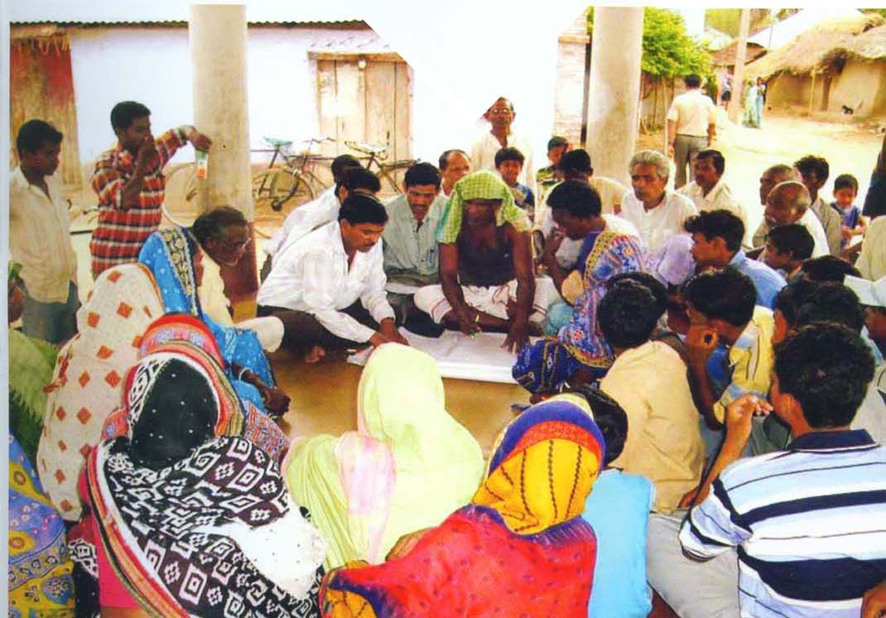 Dr. Bathula Sanjeevarayudu has relentlessly worked in the field of women and child welfare, Eradication of poverty ,Rural development , Disable , widows, aged, Orphans welfare, Youth development , Peace building in India, Pakistan, Afganistan, Sri lanka, Bangladesh, Burma countries eco development, , villages development programmes for last 32 years, Dr.Bathula Sanjeevarayudu has faced many life threatening situations while implementing all welfare and development programmes and Govt. Programmes also. he has played a major role in educating people to give up the ritual of superstitions in Rural areas.

**CONTACT ADDRESS:** Cell No: 9849092941

Excecutive secretary , Dr.Bathula Sanjeevarayudu

PSSEDUCATIONAL DEVELOPMENT SOCIETY, www.psseds.org

ERRGUDURU – 518442 , PAMULAPADU MANDAL

KURNOOL DISTRICT. ,ANDHRA PRADESH, *INDIA, https://www.facebook.com/bathula.sanjeevarayudu,*

Email:[psseds123@gmail.com](mailto:psseds123@gmail.com) <https://www.facebook.com/PSS-Educational-Development-society-NGO> ,

<https://plus.google.com/+DrBathulaSanjeevarayudupsseducationaldevsociety>

https://www.facebook.com/DrBathulaBlueCrossYouthSevaSanghamRegdNGOINDIA

http://business.google.com/website/drbathula-sanjeevarayudu



 Shunned by their own families, thousands of Hindu widows make their way to the holy city of Kurnool of Andhrapradesh India to find solace. But most also end up impoverished and neglected. Many conservative Indian families see widows as a liability. Cast out of the family home, they live the rest of their lives in poverty and isolation. A woman deprived, abandoned, malnourished naturally has a high mortality rate.  
  
On the [#InternationalWidowsDay](https://www.facebook.com/hashtag/internationalwidowsday), we recognize the work being done by PSS. Educational Development society towards improving the conditions of widows by providing education, health care , vocational training and stipends.  
  
But to make a difference in the longer term, traditional values will have to change and anti-widow discrimination will have to be a priority. The last draft of the Action Plans by the NCW and Ministry of Women and Child Development treat the women as victims, without dignity or agency. There is a need to think beyond infrastructure and vocational training when it comes to rehabilitation of widows. This is not to say that shelter homes, training and linkages to legal and medical services are not important. What is also required is to examine underlying issues of vulnerability of these widows, and follow an approach where they are economically empowered to take their own decisions. Organised conference on child rights, and Implementation of related laws in south India ,Juveline Justice , care and protection of children act-2015, and the protection of children from sexual offences, POSCO act 2012 for southern regions of India, Dr. Bathula sanjeevarayudu dedicatedly doing on the rehabilitation & reintegration of children in need of care & protection and children in conflict  with law, He fighted deaths of children at a govt Hospitals, private hospitals, girls sexual abuses, denial of treatments to an Hiv positive pregnant women ,children and harash of police actions, etc, Eradicate blind belief of offering girl child to goddess Mathamma in Tamilnadu, Andhrapradesh state of India, Dr. Bathula Sanjeevarayudu doing with co-operation of National human rights commission, A.P. state human rights commission, Lokayuktha, Delhi High court, and other UNO Agencies, Food, Health, Education Shelter basic rights to children fighted on this issues

